Spring REST using Spring Boot 3
1. spring-rest-handson:
i) Create a Spring Web Project using Maven
Spring initializer:
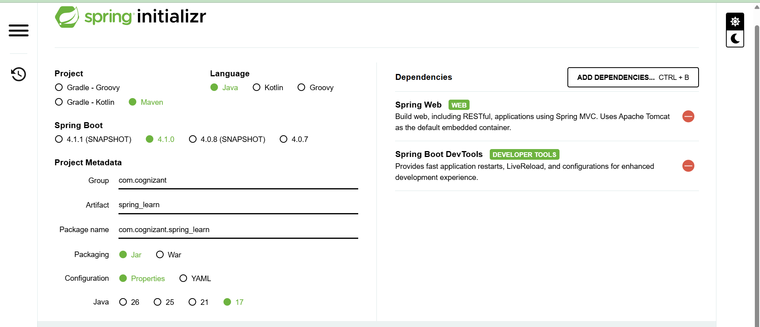
pom.xml :
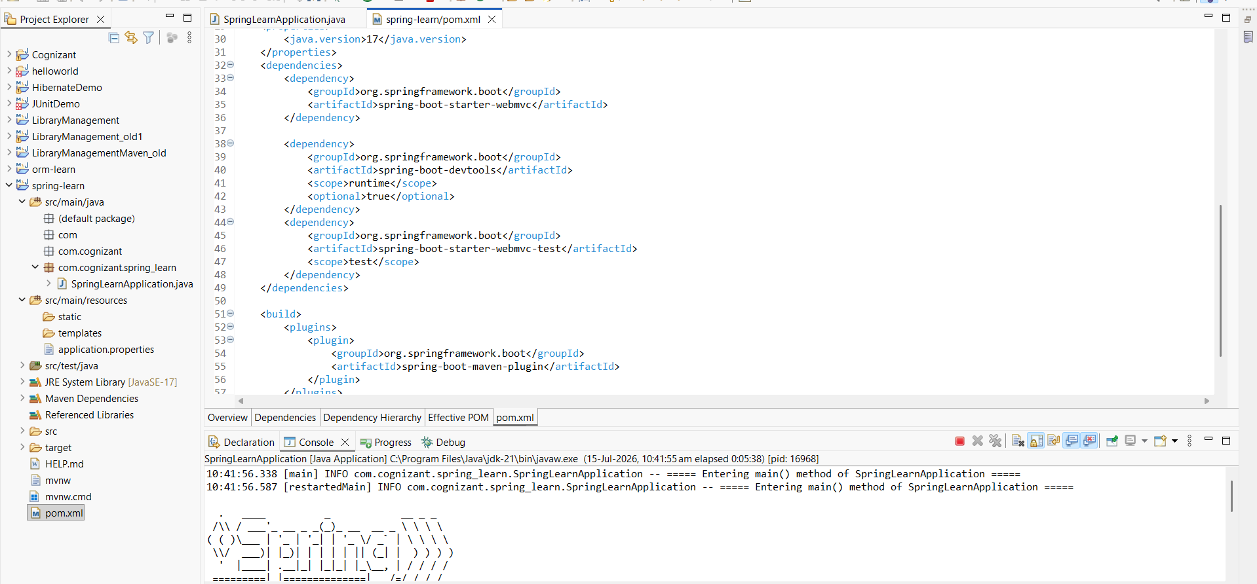

SpringLearnApplication.java :
package com.cognizant.spring_learn;

import org.slf4j.Logger;
import org.slf4j.LoggerFactory;
import org.springframework.boot.SpringApplication;
import org.springframework.boot.autoconfigure.SpringBootApplication;

@SpringBootApplication
public class SpringLearnApplication {

private static final Logger logger = LoggerFactory.getLogger(SpringLearnApplication.class);

public static void main(String[] args) {
logger.info("===== Entering main() method of SpringLearnApplication =====");
SpringApplication.run(SpringLearnApplication.class, args);
logger.info("===== SpringLearnApplication started successfully =====");
}
}

